MONTESSORINEWS

SOLDOTNA MONTESSORI CHARTER SCHOOL
Our mission is to prepare students to become citizens with a global perspective and to enrich their academics and social awareness within a Montessori environment.

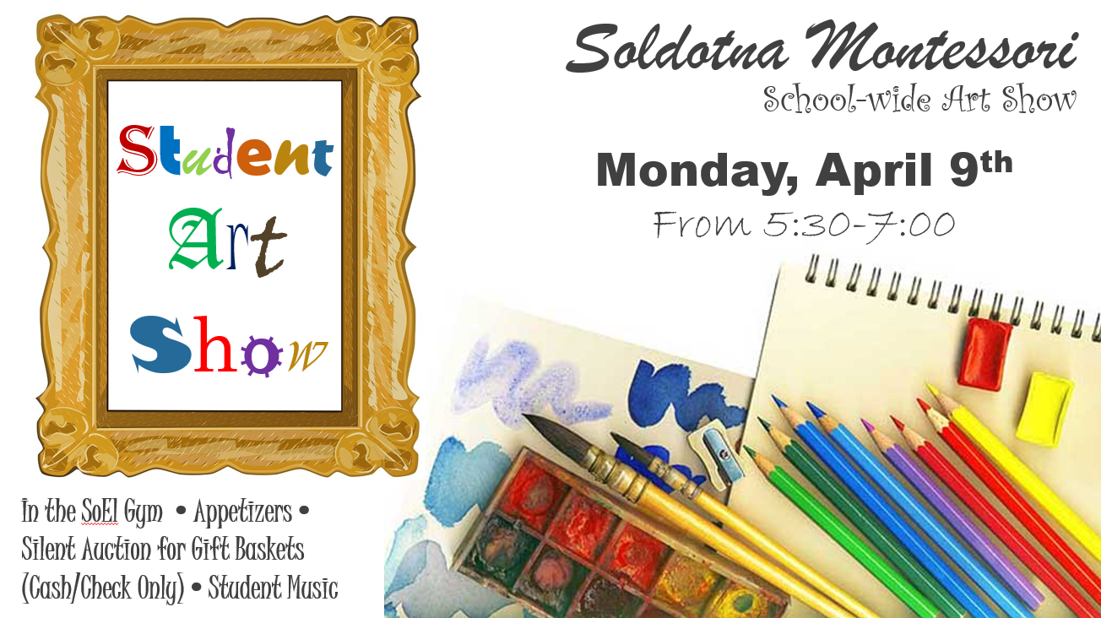
Events For Your Calendar
3/27 to 4/6 | PEAKS Testing Window (State Assessment)
3/31 | School Ice Fishing Derby Ends
4/5 | PTO Meeting @ 4:00
4/4 | Early Release Day (2:00)
4/6 | School Assembly – Carter’s Class Hosts
4/6 | 50 Cent Friday
4/9 | SMCS Annual Art Show (PTO)
4/10 | Last day to purchase a yearbook
4/12 | Kindergarten Concert @ 6:00
4/20 | No School
4/24 | APC Meeting
5/2 | ALICE Drill (AM)
5/3 | SMCS Music/Talent Show @ 6:00

Yearbooks Reminder
Time is running out to order a school yearbook; the order date has been extended to April 10th. Orders for yearbooks are being taken online @ treering.com. You can search for our school by using the term, “Soldotna Montessori.” It is advised to access treering.com with the Google Chrome browser.

Class Placement Requests – Due by April 19th
We sent home class-placement request forms in last week’s Thursday folders. The forms are primarily for parents of kindergarteners & 3rd grade students; however, anyone who wishes to make a request can return the completed form to the school by April 19th. Completion of this form is optional. We will make every effort to accommodate requests.

6th to 7th Grade Orientation Opportunities
River City Academy Open House – Thursday, April 12 @ 6:00 PM
Kenai Middle School Open House – Monday, April 30th 5:30-6:30 PM School-Day Student Visit @ KMS – April 26 OR 27 (TBD) from 9:15-11:15. Date will be updated as details are received. (Families interested in their student attending need to make arrangements on their own.)
- Early Release Next Wednesday.
- Thanks for continuing to arrive for the pick-up line no earlier than 3:30; it has been very helpful.

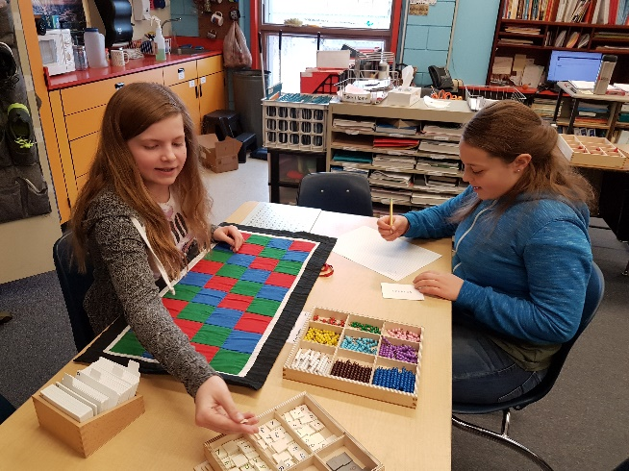

Mr. DeVolld’s Notes | Montessori & School Program Notes
A big thank you to all of the families who came and supported the Spring Carnival event. It was a HUGE success. There were a large number of participants from both schools, and the gym was filled by families having a great time together as a shared community of Soldotna Elementary and Soldotna Montessori. Events like these help our two schools work in concert with each other and allows for comradery between the two schools. Students came in superhero costumes, as did many adults. I was able to connect with students and parents from both schools running the Frog Hop Booth. Staffing a carnival booth is a fun experience I recommend to all.  A big thank you to our parents who also took on the enjoyment of staffing other booths. Your assistance allowed our students and families to participate in a fun event that supported a joint school effort to make improvements that benefit both schools. | Conscious Discipline Skill: Choices  Life is filled with choices. One of the most basic choices is whether to actively change ourselves or to spend our energy trying to make others change. Focusing our attention on changing others puts us in a GET mode instead of in a GIVE mode. This is discouraging both to ourselves and to others and sets us up for failure and a loss of composure. Choices involve the Power of Free Will. The Power of Free Will means that ‘I am in charge of me’ and I’m the only person who can make myself change. It also means that ‘you are in charge of you’ and you are the only person who can make yourself change. No matter how much pressure we put on someone else to behave the way we want them to, it is ultimately their choice to behave or not. When we make choices based on what we need and value we feel good. The reward center in the brain is activated and the brain releases chemicals that make us feel good. Making choices to please others, meet other’s expectations or avoid punishment has the reverse effect and can lead to depression or distress. This can result in burnout and apathy. From http://consciousdiscipline.com/
